Project Design Phase-II Customer Journey Map

|  |  |
| --- | --- |
| Team ID | PNT2022TMID13738 |
| Project Name | Project - Early forest fire detection System |
| Maximum marks | 4 Marks |

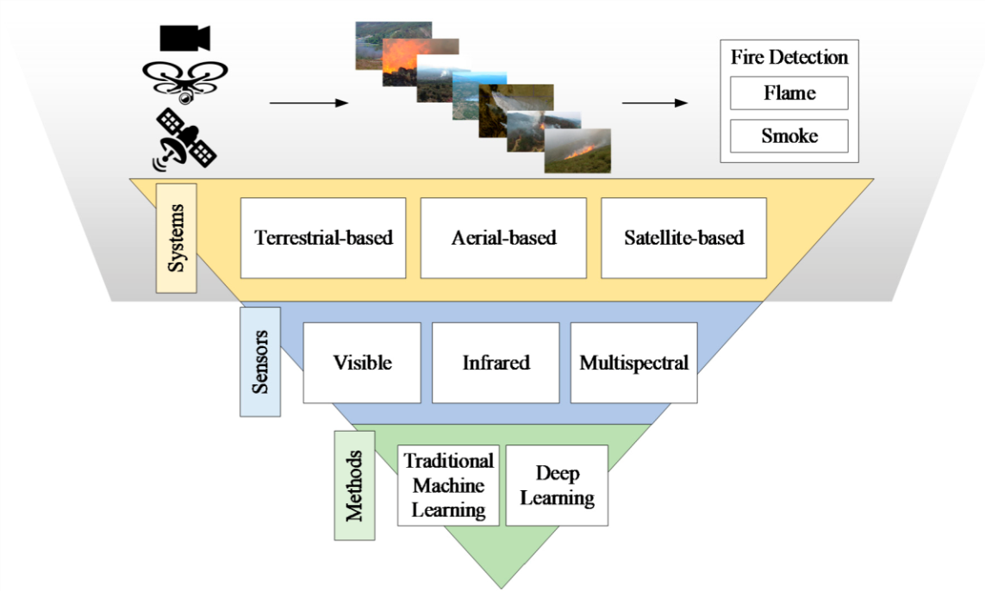Customer Journey: